Pokemon and Friends – PvP AddOn

Created By: chrizzz_1508

Version: 1.1

___________________________________________________________________________________________

Table of contents

Description 2

Patchnotes: 2

V1.0: 2

V1.1 2

Requirements 3

OBS 3

SAMMI 3

Other 3

New Installation 4

Important notes about the installation 4

Quick Guide: 4

1. Preparation 5

2. Creating the SEF file 6

3. Installing the Extension 10

4. Adding the scenes to your other scenes 10

Upgrading from V1.0.0 to V1.1.0 10

Functions 11

Fight Mechanic 11

Sturdy Mechanic 11

Setting up your Team 12

Channel Point Rewards 13

Broadcaster Commands 14

Viewer Commands 14

Changing Settings 15

FAQ 15

Special Thanks to some awesome People 17

Final notes 17

Support me 18

# Description

This AddOn works only with SAMMI and the Pokémon and Friends Mod. It lets your viewers fight either with their own Pokémon or with random Pokémon.

# Patchnotes:

V1.0:

- Creation of the PvP – AddOn

V1.1

- Added Gym Leader battles for 9 regions with over 100 challengers, defeating all challengers of a region gives you a permanent +1% catch rate

- Added new commands (**!shuffleteam**, **!kanto, !johto**, ... , **!galar**, **!customregion**, **!region 1**, **!poke-stats, !bonuscatchrate**)

- Added the ability to increase the catch rate for the current champ

- Limited teams to 1 mega or legendary Pokémon to keep the teams balanced

- Added a lot of new attack animations (huge Shoutout to ShadowEnigmaTV)

- Refunds the channel points of an ongoing fight in case you use **!pvp-init**, close SAMMI or when SAMMI crashes

- Switched the version to a SAMMI compatible version (LB2 is not working anymore)

- Switched database to CSV files (this AddOn now requires Version V1.2.0+ of the PaF Mod to run)

# Requirements

In order to install this project, you must have the following software installed properly. Please refer to the installation guide/steps that are provided by the creators of the software.

OBS

[OBS Studio](https://obsproject.com/) V27 (V28 is not recommended but also works, but only with OBSWS 4.9.1)

SAMMI

[SAMMI V2022.4.1+](https://github.com/SAMMISolutions/SAMMI-Official/releases)

[Pokemon and Friends Mod V1.2.0+](https://ko-fi.com/s/aa74935ab0)

Other

[Maximum of 44 Channel Point Rewards](https://link.twitch.tv/myChannelPoints) (this app needs to be able to create up to 5 new rewards)

[.Net Framework 3.5](https://www.microsoft.com/en-us/download/details.aspx?id=21)

[Pokémon Font](https://drive.google.com/uc?export=download&id=1oNlm5WDVYA46RIc_jIRsq_F2FvQmjfs4)¹

¹ Install the font while OBS is closed. If you install fonts while OBS is open it won't recognize it until you re-launch OBS.

# New Installation

## **Important notes about the installation**

Do NOT create Channel Points rewards yourself in Twitch, these rewards are created  
automatically in the installation process.  
If this doesn't work, try deleting the existing ones and run the **!pvp-install** command again.

Feel free to customize the color, picture, description, and even the reward cost.

The name can only be adjusted in the PvP Installer before creating the channel points. If you want to change it later, you will have to adjust the triggers in the “**PaF - PvP Add On**” Deck as well.

## **Quick Guide:**

1) Make sure that the base game is installed

2) Run the “***PaF - PvP Installer.exe***” and fill out your settings (you can hover the options for more infos)

3) Start OBS and SAMMI and make sure both are connected

4) Inside SAMMI install the newly created extension (***PaF_PvP_AddOn.sef***)

5) Wait until everything is installed. This might take up to 5min (A message will pop up when it was successful)

## **Preparation**

Make sure that you have the ***Pokemon and Friends Mod V1.2.0*** or higher installed. You can check this by looking inside the “**Pokemon and Friends Mod**” Deck in the lower left corner or by typing **!poke-version** in your chat.

Also make sure to delete all PvP channel point rewards on twitch.

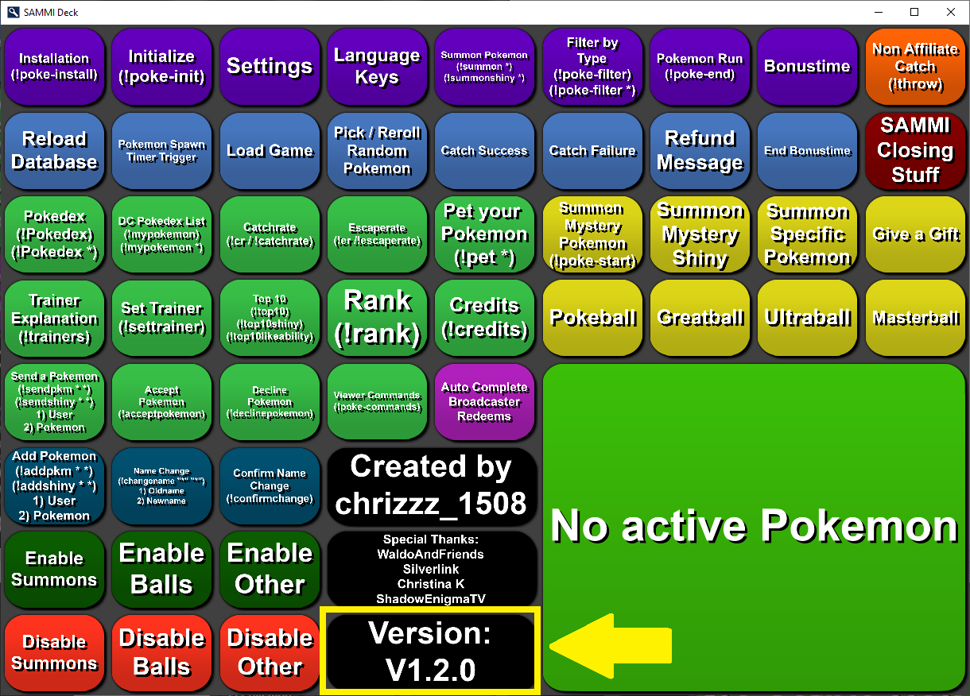

## **Creating the SEF file**

* 1. Run the **PaF – PvP Installer**

If the installer won’t start because it’s getting recognized as a security threat, this has to do with it being not signed. In that case you might have to manually allow it to be run. To do this, first click “***More Info***” and then “***Run anyway***”

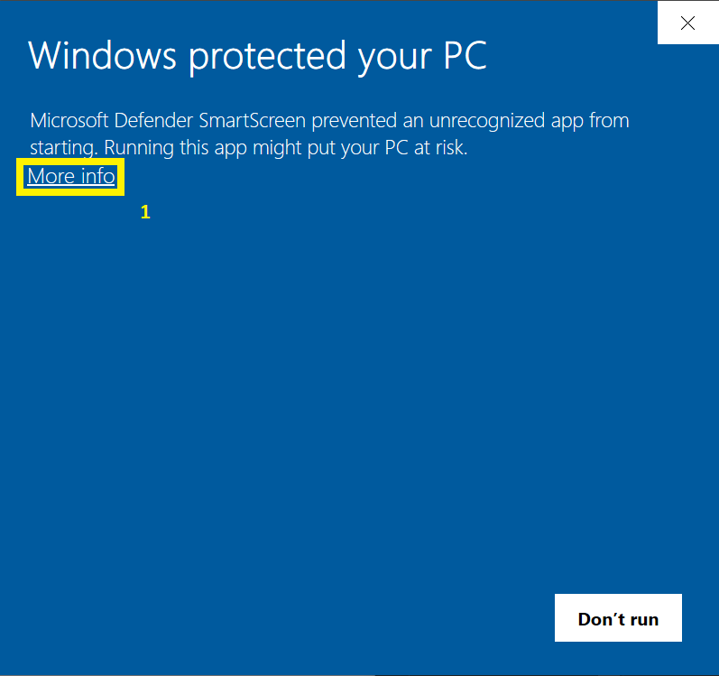

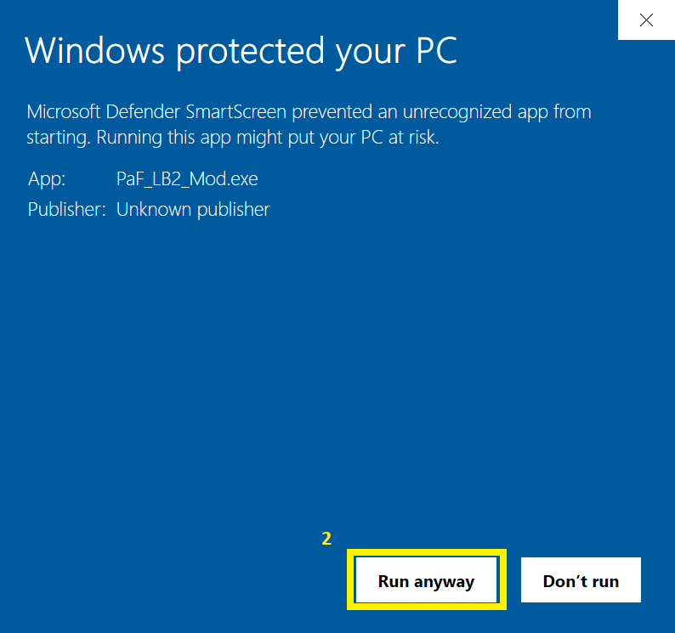

The complete code is available here so in case you think it might be malicious software please check it out: https://github.com/Chrizzz-1508/PaF_PvP_Installer

* 1. Fill out all the fields

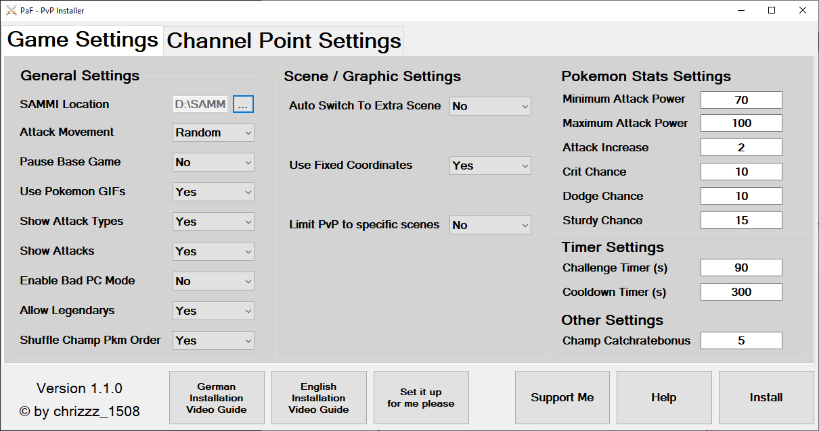

Please fill out all the settings in the installer. Here is a small overview of what each setting does:

**General Settings**

|  |  |
| --- | --- |
| **SAMMI Location** | Location of your SAMMI folder. It needs to contain the installed Pokémon and Friends Mod. |
| **Attack Movement** | Select the kind of attack movement which the Pokémon should make. |
| **Pause Base Game** | If enabled, this will cause the catching game to be paused when there is an ongoing PvP fight. |
| **Use Pokemon GIFs** | Use Gifs for the Pokémon when they exist. Else PNG files will be used. |
| **Show Attack Types** | Show the type of attack that was used in the textbox. For example fire, water, ice,... |
| **Show Attacks** | Show the actual move of the attack. This will play a small video animation and a sound. |
| **Enable Bad PC Mode** | Enable this only when your PC is really slow. Will reduce / disable some of the animations. |
| **Allow Legendarys** | When turned on, viewers can add legendarys to their teams. |
| **Shuffle Champ Pkm Order** | Each time your viewers fight the champ, the order of the Pokémon will be randomized to prevent counter picking. |

**Scene / Graphic Settings**

|  |  |
| --- | --- |
| **Auto Switch To Extra Scene** | Enable this feature to automatically switch to another scene as long as a fight is going on, after the fight is over, it will return to the previous scene automatically. Enter the exact scene name which you want to use for this feature into the "Switch Scene Name" field. |
| **Switch Scene Name** |
| **Use Fixed Coordinates** | Auto resets the position of everything to the default position when turned on. When this is turned off, you can use **!pvp-setpostion** to see the position of everything and place the sources however you want. |
| **Pokemon Size Modifier** | Change this value if you want to make the Pokémon smaller / bigger. Only works when "Use Fixed Coordinates" is turned off. |
| **Limit PvP to specific scenes** | Turn on to disable the PvP rewards in all scenes, except the scenes which you specify in the allowed scenes textbox. Please write only 1 scene per line and make sure you spell them correctly. |
| **Allowed Scenes** |

**Pokémon Stats Settings**

|  |  |
| --- | --- |
| **Minimum Attack Power** | Minimum Power of the Attack Move |
| **Maximum Attack Power** | Maximum Power of the Attack Move |
| **Attack Increase** | Increase the DMG by a certain amount (in the base games this value is 2) |
| **Crit Chance** | Chance to land a critical hit |
| **Dodge Chance** | Chance to dodge |
| **Sturdy Chance** | Maximum chance to survive an attack with 1HP. The higher the likeability of the trainer, the easier this is to get triggered. |

**Timer Settings**

|  |  |
| --- | --- |
| **Minimum Attack Power** | Minimum Power of the Attack Move |
| **Challenge Timer (s)** | Amount of time (in seconds) which everybody has to accept a PvP Challenge |
| **Cooldown Timer (s)** | Amount of time (in seconds) until the PvP rewards will be re-enabled after the fights |

**Other Settings**

|  |  |
| --- | --- |
| **Minimum Attack Power** | Minimum Power of the Attack Move |
| **Champ Catchratebonus** | This value get’s added on top of the catchrate for the current champ |

**Channel Point Settings**

Ein Bild, das Tisch enthält.

Here you can change the names / prices of the challenge point rewards and you can select if you want to use them.

The fight vs the champ is a 6vs6 fight with your own Pokémon and if you win, you will become the new champ.

The normal fights are fought with your own Pokémon (viewers will have to set their team first with **!setteam <name>, … , <name>** or **!setslot<position> <name>**.

In the random fight, each trainer will get randomly assigned Pokémon without having to own them.

**Other information**

When you are done with the settings, please press “***Install***” to create the necessary files and to create the extension file for SAMMI.

If you are not sure what the settings mean, you can just hover over a setting name with the mouse and a small description will pop up. After you have selected all your settings, please press the install button.

## **Installing the Extension**

Make sure that SAMMI and OBS are connected and that all 5 lamps are green (4 inside SAMMI and 1 in the SAMMI Bridge inside OBS.

Ein Bild, das Text enthält.
Ein Bild, das Text enthält.

Then inside SAMMI click on “***Bridge***” 🡺 “***Install an Extension***” and select the “***PaF_PvP_AddOn.sef***” in your SAMMI 🡺 Pokemon and Friends folder.

This will install the PvP AddOn and automatically generate all the necessary scenes and channel point rewards (if you are not using the non-affiliate mode).

The whole process might take up to 5 minutes and it’s recommended to not touch anything until the confirmation message pops up.

## **Adding the scenes to your other scenes**

To add the game to your other scenes, please use nested scenes.

You can do this by adding a new source to the scene where you want to use it. Then select scene and select the **PaF - PvP Scene** and if you want, you can also select the **PaF - Textbox Scene**.

# Upgrading from V1.0.0 to V1.1.0

1. Delete all the existing Channel Point rewards
2. Make sure that the **PaF Mod V1.2.0+** is installed
3. Fill out the settings in the PvP installer and hit ***install***
4. In SAMMI hit ***Bridge*** => ***Install Extension***
5. Select the new “***PaF_PvP_AddOn.sef***”
6. If you are asked for replacing the current files (extension and deck), select ***yes***.
7. If you are asked to recreate the channel points select ***yes***
8. If you are asked to recreate scenes, select ***no***.

# Functions

## **Fight Mechanic**

The fights are turn based and fully automatic. Depending on the SPD stat of the Pokémon it is decided which Pokémon attacks first. But even when the Pokémon is fast, there is a certain chance that the other Pokémon will hit first (the max chance to attack first is currently set to 70 / 30).

Each Pokémon will attack with the element that’s more effective, so a (Fire | Electro) type will always use electro attacks vs a water element.

There is a certain chance for Pokémon to crit and dodge attacks.

The damage is calculated with the stats of the Pokémon (base stats are raised to LV100) and ATK and DEF as well as type advantages and crits / dodges play a role.

Whenever a new Pokémon comes in, it’s checked again which Pokémon comes first.

## **Sturdy Mechanic**

The Pokémon also have a chance to survive hits with 1HP. This is affected by the likeability of their trainers (this can be increased once per stream by petting any of their Pokémon with the **!pet <Name>** command). The higher the likeability of the trainer, the easier it is to proc sturdiness.

It also depends on the highest likeability of all trainers (the highest likeability is at least 20).

So, if you set the sturdy chance to 15%, the one with the highest likeability always will have a 15% chance for each of his Pokémon to survive a hit with 1HP.

The sturdy chance for other players is based on the highest likeability that has been achieved by all trainers.

Here is an example:

Sturdy Chance is set to 20%

P1 has 50 Likeability

P2 has 25 Likeability

When the highest achieved likeability is 50, then P1 would have a 20% chance to trigger sturdiness and P2 would have 10%.

But if there is a player that has 100 likeability, then that means that P1 gets only a 10% chance to proc sturdy, and P2 has only a 5% chance.

## **Setting up your Team**

For normal fights, the viewers need to setup their team first. They can do this with the **!setteam <name>, … , <name>** or **!setslot<position> <name>** command.

For the name they can use any supported language or the number of the Pokémon.

Case sensitivity only matters when the Pokémon contains any special characters.

If the player has only 1 form of that Pokémon (either shiny or normal) that one is selected automatically.

You can use 1 shiny and 1 normal form of each Pokémon.

Also teams can only contain 1 legendary / mythical or mega Pokémon.

But if the player has both forms, they need to add (s) to the name part if they want to use the shiny version.

It’s recommended to use **!mypokemon** before creating a team, so that you can check which Pokémon you have on Discord.

To set a full team the command could possibly look like this:

**!setteam Gyarados, Bulbasaur, Mewtwo (s), Abra, Dragonite, Charizard**

or

**!setteam 1, 2 (s), 3(shiny), shiny 4, 5, 6**

## **Channel Point Rewards**

**PvP - Challenge the Champ** – Fight against the current champ. It’s a 6vs6 fight with your own Pokémon and if you win, you will become the new champ (viewers will have to set their team first with **!setteam <name>, … , <name>** or **!setslot<position> <name>**).

**PvP - Normal 3vs3 / 6vs6** - Starts a normal fight. Fights are fought with your own Pokémon (viewers will have to set their team first with **!setteam <name>, … , <name>** or **!setslot<position> <name>**). If you want to challenge someone specific, enter their name, else use either: **anyone**, **any**, **everyone**, **rnd**, **random**, **alle** or **jeden**. To accept a challenge, the challenged viewer needs to write **!fight** in the chat.

**PvP - Random 3vs3 / 6vs6** - Starts a random fight. Fights are fought with randomly assigned Pokémon. The viewers don’t have to own them. If you want to challenge someone specific, enter their name, else use either: **anyone**, **any**, **everyone**, **rnd**, **random**, **alle** or **jeden**. To accept a challenge, the challenged viewer needs to write **!fight** in the chat.

**PvP - Challenge a region** - Starts a normal 6vs6 fight vs a Gym Leader / Elite Four / Champ of the region you have selected. Currently there are 9 regions available:

1) Kanto 2) Johto 3) Hoenn 4) Sinnoh 5) Unova 6) Kalos 7) Alola 8) Galar 10) Custom

The custom region is made from custom people who were involved in this project and some cool other trainers like Professor Oak.

If you challenge a region, it will first select randomly one of the gym leaders which you haven’t defeated yet, then if you have defeated all of them, the elite four are next and if you also have defeated them, the champ is the last challenger of that region.

If you have defeated all challengers of a region, you will gain a permanent +1% catch rate and will be matched against a random challenger of the region.

You can always check your current progress with **!kanto**, **!johto**, … **!galar**, **!customregion**, **!region 1**.

## **Broadcaster Commands**

**!pvp-install** - Starts the Installation of the modified version (only needed when you are having troubles and it doesn’t start automatically)

**!pvp-init** - Resets the game and loads the settings / language keys (needed after changing the settings)

**!setfight** - Forces a fight between 2 users. Also works directly with using **!setfight <trainer1> <trainer2><pokemoncount> <random?>**

**!poke-pause** **/ !poke-continue** - Pauses / continues the catching game

**!resetchamp** - Resets the current champ back to the default settings

**!pvp-setposition** - Makes all sources visible to reposition them. Only works with fixed coordinates turned off.

## **Viewer Commands**

**!pvp-commands** - Shows a list of the available commands

**!setslot<number> <name>** - Set a Pokémon for a specific slot, you can either use the name or the number of the Pokémon.

**!setteam <name>,...,<name>** - Use this command to set multiple Pokémon at once

**!clearteam** - Removes all Pokémon from your team

**!champ** - Shows information about the current champ

**!fight** - Use this to accept a PvP challenge

**!mypvp** - Shows information about your PvP stats

**!top10wins / !top10defeats / !top10winrate** - Shows the leaderboards

**!shuffleteam** - Shuffles your team order randomly without showing the new one in chat

**!kanto, !johto**, ... , **!galar**, **!customregion**, **!region 1** - Shows your progress of the selected region

**!bonuscatchrate** - Shows your current bonus catch rate

**!poke-stats** - Shows a link to a google drive document where all the Pokémon are listed with their stats

( https://docs.google.com/spreadsheets/d/1ywh5pwNSWo40rg15b-8pyci8RWCYYr08vxQwNANCSao )

## **Changing Settings**

You can easily change the settings in SAMMI directly by double-clicking the “***PVP Initialize Settings***” button in the **PaF - PvP Add On** deck. After changing something, either restart SAMMI or type **!pvp-init** into the chat.

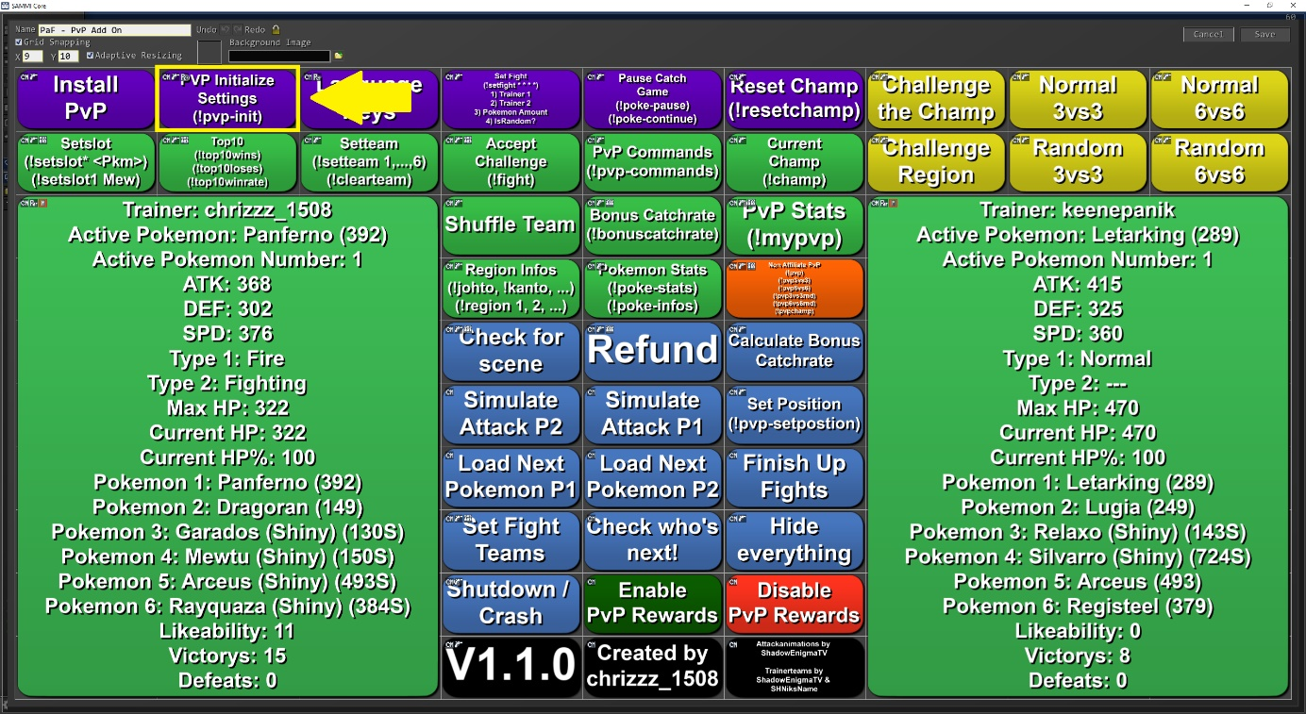

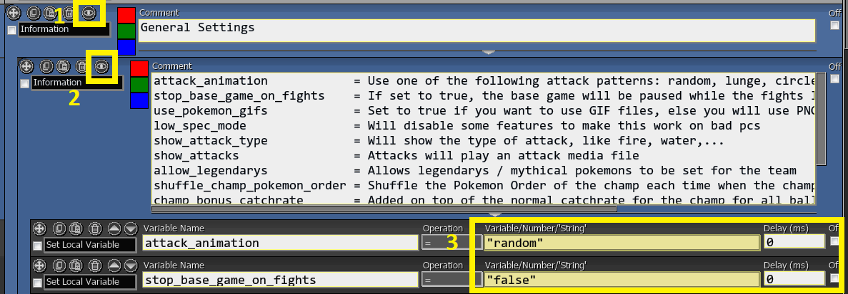

# FAQ

**I have no sound | How can I change the volume?**

By default, only your viewers will hear the sounds.

You can change the settings in the OBS Advanced audio properties (right click the audio mixer 🡺 advanced audio properties 🡺 uncheck the "Active Sources Only" box and scroll to sounds you want to hear. The following sounds exist:

* PvP - Attack 1
* PvP - Attack 2
* SFX - Pokemon Cry 1
* SFX - Pokemon Cry 2
* SFX - Battle Music

There you can change the volume (except for the Battle Music) and if you want to hear them yourself, you can turn the monitoring on.

For the battle music, you will have to right click it =>select ***Filter*** and then edit the ***Limiter Filter***.

# Special Thanks to some awesome People

[**Anni**](https://www.twitch.tv/keenepanik)- The best fiancée I could wish for

[**ShadowEnigmaTV**](https://linktr.ee/shadowenigmatv) - Creating all the graphic files and motivating me to do this

[**Doc Simpson**](https://linktr.ee/Doc_Simpson) - Creating a german tutorial video

[**Pandamonium**](https://www.twitch.tv/pandamoniummj)- French Translation

[**DrNiCoH**](https://www.twitch.tv/drnicoh) - Spanish Translation

**al3xzandru** - Italian Translation

And of course, all the awesome beta testers!

# Final notes

If any problems occur during the installation, please make sure that you've followed all steps correctly and all prerequisites were installed / updated accordingly.

If the problem still persists you can get support on

[**my Discord Server (https:/discord.com/invite/A3VF9kW)**](https://discord.com/invite/A3VF9kW)

Thanks for downloading!



# Support me

Hey everyone,

my name is Chrizzz and I'm a C# developer that loves to create fun stuff.

This content is completely free. But if you feel like you want to leave me a tip, I would really appreciate it!

You can tip me via PayPal here:

[](https://www.paypal.com/paypalme/chrizzz1508)

<https://www.paypal.com/paypalme/chrizzz1508>

I'm also a streamer on Twitch! Please feel free to also drop by in my stream over at twitch and hang out with me.

[](https://twitch.tv/chrizzz_1508)

<https://twitch.tv/chrizzz_1508>

I would love to meet you!

Thank you for using this modified version of Pokémon and Friends!

I truly hope you love it!